**Manual Testing Interview Q&A**

**Q1. What is Software?**

**Ans:-** Software is a collection of computer programs that helps us to perform a task.

Types of Software:

1. **System Software** – Device Drivers, Operating systems, Servers, Utilities etc.
2. **Programming Software** – Compiler, Debugger, Interpreter etc.
3. **Application Software** – Web Applications, Mobile Applications, Desktop Applications etc.

**Q2. What is Software Testing?**

**Ans:-** Software testing is a part of software development process. Software Testing is an activity to detect and identify defects in the software. The Objective of testing is to release a quality product to the client.

**Q3. What is Software Quality?**

**Ans:-** Software Quality is simply a field of study where we describe attributes of the software products.Based on below parameter we can say whether software has quality or not. – Bug-Free, Delivered on time, within budget, Meets Customer Requirements/Expectation, User friendly etc.

Factors of Software Quality:

1. Portable
2. Reusable
3. Maintainable – Easily correctable the error, New functionality should easily added
4. Reliable – Good Performance
5. Efficiency – It should use less CPU time, memory.

**Q4. What are the three C’s of Software Quality?**

**Ans:-** The three C’s of Software Quality is Consistency, Completeness, and Correctness.

**Q5. Project Vs Product?**

**Ans:-** If software application is developed for ‘specific customer’, based on their requirement is called as **Project.**

If software application is developed for ‘multiple customer’, based on the market requirement is called as **Product.**

**Q6. Difference betweem Error, Fault, Bug/Defect and Failure?**

### Ans:-

### Error: An error is a mistake made by a human that leads to a discrepancy between the actual and the expected result.

### Defect: A defect is a problem in the functioning of a software system during testing. ISTQB defines a defect as “A flaw in a component or system that can cause the component or system to fail to perform its required function, e.g., an incorrect statement or data definition.”

### Fault: A fault is an incorrect step, process, or data definition in a software product.

### Bug: A bug is a flaw in a software system that causes the system to behave in an unintended manner.

### Failure: A failure is the inability of a software system to perform its operations within the specified performance benchmark. As per ISTQB, “a defect, if encountered during execution, may cause a failure of the component or system”.

So, we can say that a mistake made by humans during coding is called an **error**, an error found during the testing phase is called a **defect**, a defect to be resolved by the development team is called a **bug** and when a build does not meet its specifications then it is termed as **failure**.

**Q7. What is SDLC?**

**Ans:-** SDLC stands for Software Development Life Cycle. It describes the various phases involved in the software development process. With the help of SDLC, we can create software applications in a well-defined and systematic way.

The different phases of the Software Development Life Cycle are-

* Requirement Gathering and Analysis – In this phase, all the requirements are gathered and analyzed for their feasibility.
* Designing – In this phase, the requirement specifications are converted into design specifications.
* Coding/Implementation – Actual coding is done here.
* Testing – This phase involves testing the software product.
* Deployment – The software is deployed to production for the end user.
* Maintenance – Due to changes in the environment and for continuous improvement maintenance is required.

**Q8. What is STLC? What are phases of STLC life cycle?**

**Ans:-** STLC stands for the Software testing life cycle. It refers to all these activities performed during the testing of a software product. Basically, it provides a sequence of activities performed to ensure the quality of the software application.

The different phases of the Software Testing Life Cycle are-

* **Requirement Analysis** – In this phase, the high-level analysis of the requirements is done.
* **Test Planning** – In this phase, a test strategy and approach are defined.
* **Test Case Development** – The test cases are created in this phase.
* **Test Environment Setup** – Here, the test environment is created in which the test execution will be performed.
* **Test Execution** – Test cases are executed and defects are logged for the failed tests.
* **Bug Reporting and Tracking** – Reporting a defect and verifying a defect once it is fixed.
* **Test Closure** – A test closure document is prepared which contains all the testing activities performed and the bugs found. This phase marks the formal closure of the testing phase.

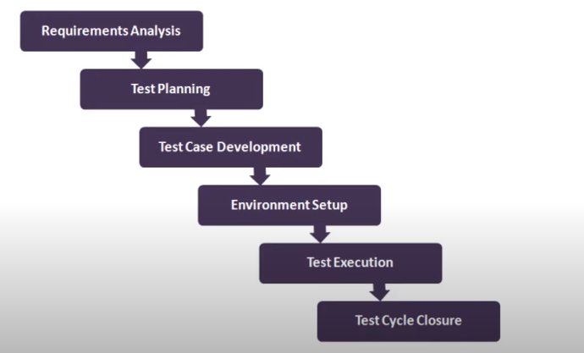

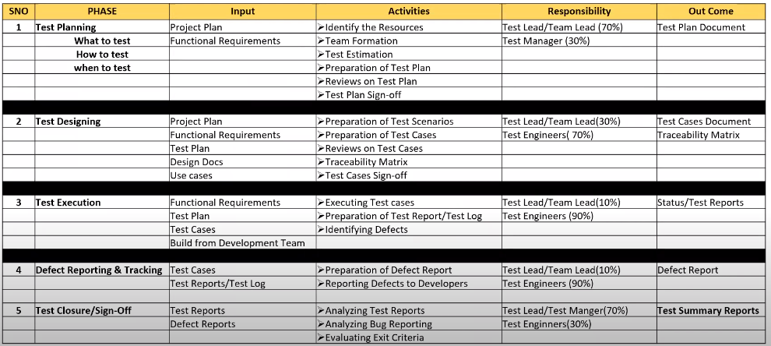

| **Entry Criteria** | **Activity** | **Exit Criteria** | **Deliverables** |
| --- | --- | --- | --- |
| **Requirement Analysis** | | | |
| - Requirements Document available (both functional and non-functional)  -Acceptance criteria defined.  -Application architectural document available. | -Analyse business functionality to know the business modules and module specific functionalities.  -Identify all transactions in the modules.  -Identify all the user profiles.  -Gather user interface/ authentication, geographic spread requirements.  -Identify types of tests to be performed.  -Gather details about testing priorities and focus.  -Prepare Requirement[Traceability Matrix](https://www.guru99.com/traceability-matrix.html)(RTM).  -Identify test environment details where testing is supposed to be carried out.  -Automation feasibility analysis (if required). | -Signed off RTM  - Test automation feasibility report signed off by the client | -RTM  -Automation feasibility report (if applicable) |
| **Test Planning** | | | |
| -Requirements Documents -Requirement Traceability matrix. -Test automation feasibility document. | -Analyze various testing approaches available -Finalize on the best-suited approach -Preparation of test plan/strategy document for various types of testing -Test tool selection -Test effort estimation -Resource planning and determining roles and responsibilities. | -Approved test plan/strategy document. -Effort estimation document signed off. | -Test plan/strategy document. -Effort estimation document. |
| **Test case development** | | | |
| -Requirements Documents RTM and test plan Automation analysis report | -Create test cases, test design, automation scripts (where applicable) -Review and baseline test cases and scripts -Create test data | -Reviewed and signed test Cases/scripts -Reviewed and signed test data | -Test cases/scripts -Test data |
| **Test Environment setup** | | | |
| -System Design and architecture documents are available -Environment set-up plan is available | -Understand the required architecture, environment set-up -Prepare hardware and software development requirement list -Finalize connectivity requirements -Prepare environment setup checklist -Setup test Environment and test data -Perform smoke test on the build -Accept/reject the build depending on smoke test result | -Environment setup is working as per the plan and checklist -Test data setup is complete -Smoke test is successful | -Environment ready with test data set up -Smoke Test Results. |
| **Test Execution** | | | |
| **-**Baselined RTM,[Test Plan](https://www.guru99.com/what-everybody-ought-to-know-about-test-planing.html), Test case/scripts are available **-**Test environment is ready **-**Test data set up is done **-**Unit/Integration test report for the build to be tested is available | -Execute tests as per plan -Document test results, and log defects for failed cases -Update test plans/test cases, if necessary -Map defects to test cases in RTM -Retest the defect fixes -[Regression Testing](https://www.guru99.com/regression-testing.html) of application -Track the defects to closure | -All tests planned are executed -Defects logged and tracked to closure | -Completed RTM with execution status -Test cases updated with results -Defect reports |
| **Test Cycle closure** | | | |
| -Testing has been completed -Test results are available -Defect logs are available | -Evaluate cycle completion criteria based on – Time,[Test coverage](https://www.guru99.com/test-coverage-in-software-testing.html), Cost, Software Quality, Critical Business Objectives -Prepare test metrics based on the above parameters. -Document the learning out of the project -Prepare Test closure report -Qualitative and quantitative reporting of quality of the work product to the customer. -Test result analysis to find out the defect distribution by type and severity | -Test Closure report signed off by client | -Test Closure report -Test metrics |

**Q9. What is Test Plan? What it contains?**

**Ans:-** Test Plan is a document that describes the test scope, test strategy, objectives, deliverables and resources required to perform testing for a software product.

**Test Plan Template contents:**

* Overview
* Scope – Which feature/functionality should cover and which not. What to test, What not to Test and how to test
* Test Strategy – Regression, Sanity, Smoke etc
* Defect Reporting Procedure
* Roles and Responsibilities
* Tools
* Test Schedule – When testing should start
* Test Deliverables
* Pricing
* Entry and Exit Criteria
* Risk Mitigation

**Q10. What is Entry and Exit Criteria?**

Ans:- Entry Criteria: It gives the prerequisite items that must be completed before testing can begin.

Exit Criteria: Exit Criteria defines the items that must be completed before testing can be concluded.

**Q11. What is the Test Scenario, Test Case and Test Suite?**

Ans:-

* **Test Scenario:** is nothing but *what to be tested*.A Test Scenario is defined as any functionality that can be tested. It is a collective set of test cases which helps the testing team to determine the positive and negative characteristics of the project. Test Scenario gives a high-level idea of what we need to test.
* **Testcase:** Testcase is nothing but *how to be tested*. A Test Case is a set of actions executed to verify a particular feature or functionality of your software application. A Test Case contains test steps, test data, precondition, and post condition developed for a specific test scenario to verify any requirement.

Example:- Test Scenario: “Check the Login Functionality”

Testcase1: Check system behavior when valid email id and password is entered.

Testcase2: Check system behavior when invalid email id and valid password is entered.

Testcase3: Check Forget your password is working as expected

* **Testcase contents:** Testcase ID, Title, Description, Pre-condition, Priority / Tags, Requirement Id, Steps, Expected Result, Testdata,
* **TestSuite:** Test suite is a group of test cases which belongs to same category. It is a bulk of similar feature or functionality or module.

Example:- Regression suite, Sanity suite, functional suite

**Q12. What are the best practices for writing test cases?**

Ans:-

* Write test cases with end-users perspective
* Write test steps in a simple way that anyone can follow them easily
* Make the test cases reusable
* Set the priority
* Provide a test case description, test data, expected result, precondition, post condition.
* Write invalid test cases along with valid test cases
* Follow proper naming conventions
* Review the test cases regularly and update them if necessary.

**Q13. What process you follow to write a new Testcase? How do you write a Testcase?**

Ans:-

1. Whenever new feature comes in then the first step is to understand the workflow / requirements of the new feature.
2. Talk to Developer and understand the workflow.
3. Clarify the doubts if you have
4. Document the high level scenarios
5. Apply design techniques (Equivalence Partition, Boundary Value Analysis, State Transition whichever required) to cover all kind of scenarios which will cover all positive and negative scenarios.
6. Prepare the precondition, test data, expected result etc.
7. Write down the testcase scenarios and steps
8. Review those scenarios and steps from senior colleague if everything is good then start developing test steps. If any review comments are there then work on review comments.
9. Once Testcase development is done. Then execute those testcases in a batch and check the passing percentage.

**Q14. What is the Test Strategy? What are the Test Strategies you have used?**

Ans:- Test Strategy describer what kind of testing we are going to conduct. Like Regression, functional, sanity, smoke,

**Q15. What is RTM (Requirement Traceability Matrix)? RTM Template?**

Ans:- RTM describes the mapping of requirements with testcases.

* The main purpose of RTM is to see that all testcases are covered, so that no functionality should miss while doing software testing.
* Test engineer prepare RTM and checks all testcases are covered or not.
* RTM Templates contains-> Requirement ID, Requirement Description, User Story, Testcase Id, Testcase Title, Date, Testcase Status(Passed, Failed, Manual Pass), Defect Id (If TC is failed), Testcase log
* Types of RTM: Forward Traceability, Backward Traceability, Bi-Directional Traceability

**Q16. What is Test Summary Report? What does it contains?**

Ans:- Test Summary Report is an important document that is prepared at the end of a Testing project. The prime objective of this document is to explain the details of the Testing activities performed for the Project, to the respective stakeholders like Senior Management, Clients, etc. It also portrays the overall quality level of the application. It provides the relevant stakeholders with a detailed account of the overall test results and defects. It aims to summarize the results of the entire testing process formally.

Test Summary Report contains: Test Objectives, Areas covered, Areas not covered, Testing approach, Defect Report, Platform Details, Overall summary.

**Q17. What are different phases/stages of Defect Life Cycle?**

Ans:- In Software Testing defect has specific a set of states that defect goes through in its entire process.

1. **New:** When new defect is logged/raised first time.
2. **Assigned:** Once defectis raised by tester, test lead approves the defect and assigns it to developer.
3. **Open:** Developer starts analyzing a defect and start working on defect fixing.
4. **Fixed:** When the developer makes some changes and verifies the changes. Developer changes status is fixed.
5. **Retest:** Once the defect is fixed, developer gives a particular code to tester for retesting the functionality. Tester does the retesting of code at this stage to check whether the defect is fixed or not.
6. **Verified:** Once the retest is done and if there is not bug detected then defect is fixed and verified.
7. **Reopen:** If the defect occurs again then tester marks the status to reopen.
8. **Closed:** If the defect is no longer exists, tester marks the status to close.
9. **Duplicate:** If the defect is repeated twice or defect corresponds to same concept.
10. **Rejected:** Developer feels this is not a defect then it can be rejected.
11. **Deferred:** The defect is not of a prime priority or it can be fixed in next release. Then the status of that defect can be deferred.

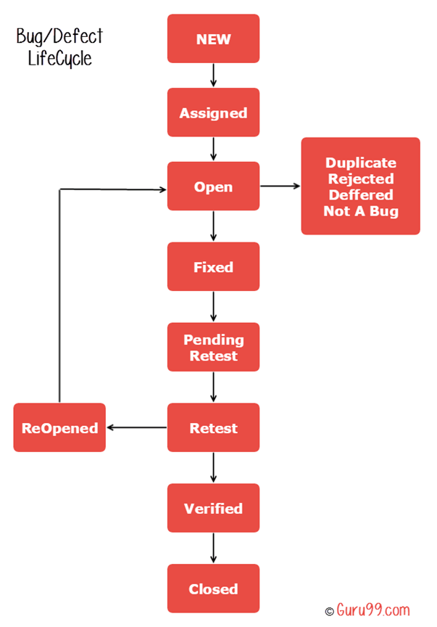

**Q18. What are the reasons of software bug?**

**Ans:-** Below are the major reasons of software bug:

* Miscommunication and misunderstanding
* Software Complexity
* Programming errors
* Changing Requirements
* Lack of skilled Tester

**Q19. What are the things you should mention while creating defect? Defect Template/Defect Report content?**

**Ans:-** Following parameter we should mention in the defect:

* Environment and Application Release
* User details
* Testcase Id and Testcase Description
* Severity and Priority
* Status
* Submitted By
* Steps to Reproduce
* Actual Result
* Expected Result
* Logs attachment
* Snapshot/Screen Recording

**Q20. What Severity and Priority?**

**Ans:-** Severity is nothing but ‘impact of the defect on the application’. Priority is nothing but ‘urgency of defect to be fixed’.

Q. What is Agile Methodology? How does it work?

Q. What are the suggestions you have given in retrospective meeting in agile methodology?

Q. What is Functional Testing?

Q. What is Unit Testing?

Q. What is Integration Testing?

Q. What is Regression Testing?

Q. What is Performance Testing?

Q. What is System Testing?

Q. What is Retesting?

Q. What is Smoke testing?

Q. What is Sanity Testing?

Q. What is API Testing?

Q What are different Test Design Techniques?

Ans:-

1. Decision Table:
2. Equivalent Class Partitioning:
3. Boundary Value Analysis:
4. State Transition:
5. Error Guessing: